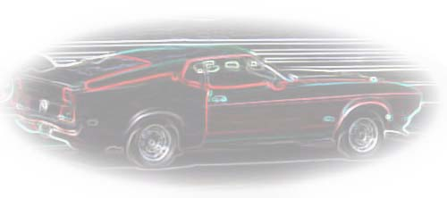
1972 Ford Mustang Mach 1

-Engine-  - 1971 429 4-V  - Forged Pistons  - Roller Rockers  - RPM Performer Intake  w/ matching Cam  - 250 Shot NOS  - Holley Blue Elec. Fuel Pump | -DriveTrain-  - Ford C-6 Trans.  - B&M Ratchet Shifter  - 4.11 Ford 9” Posi-Traction Rear End  - Cross-Drilled Brake Rotors
-Owner-

John J. J. Michalek
Plymouth, MI
Class of 2000

